Data Set 1:

Contract Purchase

Penetration Test , Server Analysis

Name: Zach Schwuchow

Address: 3126 Shortland Rd

Company Name: Cyber Sec Society

Screenshot:

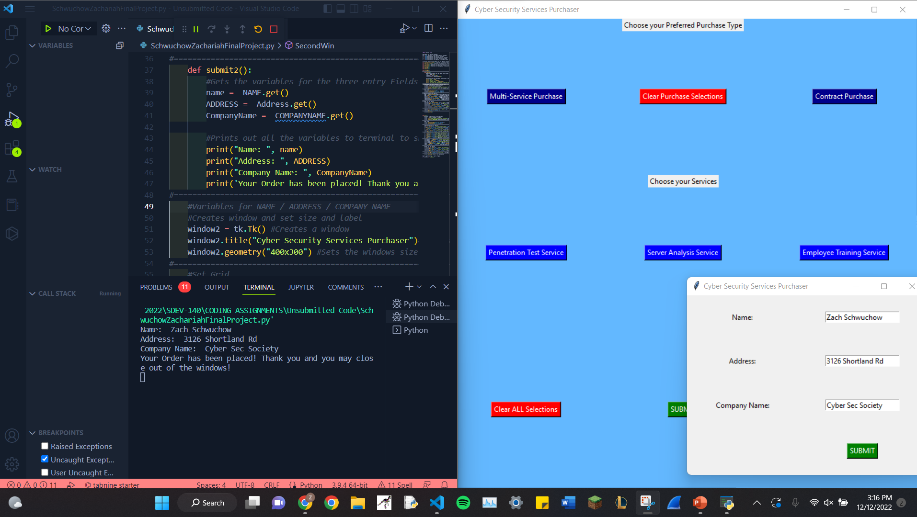

========================================================================

Data Set 2

Contract Purchase

Empoyee Training, Server Analysis

Name: Johnson Smth

Address: 1423 Gillshort Drive

Company Name: Panera

Screenshot:

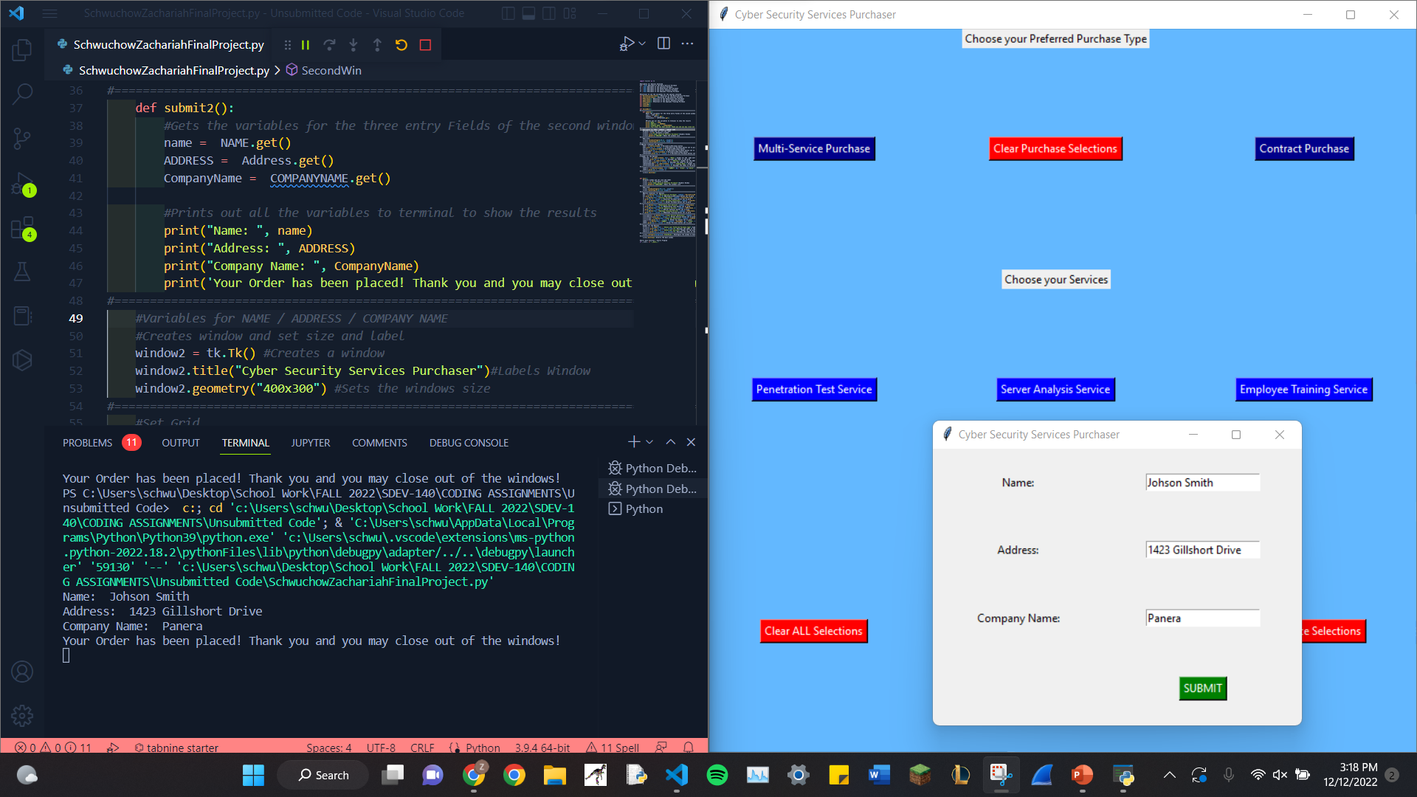

========================================================================

Data Set 3:

Multi-Service Purchase

Employee Training, Penetration test , Server Analysis

Name: Zach Schwuchow

Address: 1750 Ohio Street

Company Name: Walmart

Screenshot:



